Project 2 – Investigation of the Stroop Effect  
by Frank Fichtenmueller

**Question 1**: What is our independent Variable? What is the dependent variable?

The variable being altered in the two conditions is the congruency between word and color presentation. (The independent variable)

The dependent variable, the one possibly being influenced by the two conditions of the independent variable, is the time needed to read out all the words aloud.

**Question 2:** What is an appropriate set of hypotheses for this task? What kind of statistical test do you expect to perform?

Ho: **μC** = **μI**The population mean in both the congruent and the incongruent treatment are similarH1: **μI** > **μC**

The population in the incongruence situation shows a significant higher mean size.

Based on the given sample Data with n=24, the dependent structure of the experimental setup and as the experiment is aimed to explore if the mean difference between both treatment situations can be generalized to the population as a whole, I expect to conduct a one directional dependent t-test.   
Hereby I chose a t-test to a z-test, as with the small sample size n < 30, as a normal distribution of the sample can not be expected.

The aim is to answer the question, if the difference in the population mean from the two treatment situations are significant and can therefore be generalized to the general population.

I expect to be following a directional hypotheses, along the theoretical expectation that a dissonance in visual and literal representation of the words to be read results in a disturbance in recognition, and therefore slows down the oral replication of the stimulus materials. This must result in a higher sample mean for the second treatment condition.

Along this expectation the alternative Hypotheses formalizes this hypotheses as the significant difference of the sample mean.

**Question 3**: Report the descriptive statistics

|  |  |  |  |  |
| --- | --- | --- | --- | --- |
| **n** | 24 |  | 24 |  |
| **mean** | 14.4491 |  | 22.10 |  |
| **sd** | 3.6 |  | 4.80 |  |
|  |  |  |  |  |
| Calculating a one-tailed t-test on sample means |  |  |  |  |

**Question 4**: Visualizations:

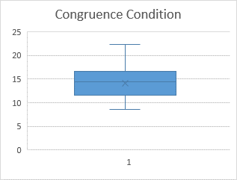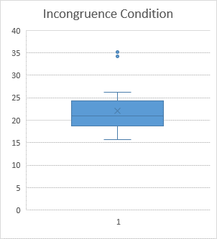

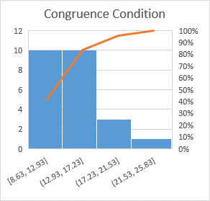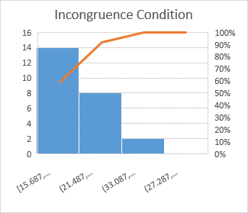

It can be clearly seen, that there is an overall increase in the Duration in sec within subjects over the two treatment. Looking at the relative frequency of Duration scores recorded between the two groups, the data is strongly positively skewed. Yet this effect seems to be stronger in the Congruent Condition.

There are two outlying datapoints in the second treatment condition, yet they are in range and do not pose any threat to the analysis.

The spread of the data seems to be stable across both treatment situations, with a little stronger spread in the Incongruence Condition.

**Question 5**: Peforming the one-tailed-t-test on the data

|  |  |  |  |  |  |  |
| --- | --- | --- | --- | --- | --- | --- |
| **Congruent** | **Incongruent** | **Difference** | **squared error** |  |  |  |
| 12.079 | 19.278 | 7.199 | 51.825601 |  | **mean(d)** | 7.96479167 |
| 16.791 | 18.741 | 1.95 | 3.8025 |  | **sd(d)** | 9.4795895 |
| 9.564 | 21.214 | 11.65 | 135.7225 |  | **SE(d)** | 1.9350131 |
| 8.63 | 15.687 | 7.057 | 49.801249 |  | **t-statistic** | **4.11614353** |
| 14.669 | 22.803 | 8.134 | 66.161956 |  | **critical t** | 1.319 |
| 12.238 | 20.878 | 8.64 | 74.6496 |  | **df** | 23 |
| 14.692 | 24.572 | 9.88 | 97.6144 |  | **Cohens d** | **0.424** |
| 8.987 | 17.394 | 8.407 | 70.677649 |  |  |  |
| 9.401 | 20.762 | 11.361 | 129.072321 |  |  |  |
| 14.48 | 26.282 | 11.802 | 139.287204 |  |  |  |
| 22.328 | 24.524 | 2.196 | 4.822416 |  |  |  |
| 15.298 | 18.644 | 3.346 | 11.195716 |  |  |  |
| 15.073 | 17.51 | 2.437 | 5.938969 |  |  |  |
| 16.929 | 20.33 | 3.401 | 11.566801 |  |  |  |
| 18.2 | 35.255 | 17.055 | 290.873025 |  |  |  |
| 12.13 | 22.158 | 10.028 | 100.560784 |  |  |  |
| 18.495 | 25.139 | 6.644 | 44.142736 |  |  |  |
| 10.639 | 20.429 | 9.79 | 95.8441 |  |  |  |
| 11.344 | 17.425 | 6.081 | 36.978561 |  |  |  |
| 12.369 | 34.288 | 21.919 | 480.442561 |  |  |  |
| 12.944 | 23.894 | 10.95 | 119.9025 |  |  |  |
| 14.233 | 17.96 | 3.727 | 13.890529 |  |  |  |
| 19.71 | 22.058 | 2.348 | 5.513104 |  |  |  |
| 16.004 | 21.157 | 5.153 | 26.553409 |  |  |  |

With with a t-score of 4.116 the result is significant at p < 0.05, with 0.42 sd difference (cohens d).

This means that there is a clear significant mean difference between the two treatment groups.

This matches the expectations both from the underlying theorie, as from the descriptive analytic of the dataset.